Printer Setup Guide

Internal User guide

Release v1.0

|  |  |
| --- | --- |
| Document Name: | DXC Sofia Printer Setup Guide |
| Prepared By: | Konstantin Lilov |
| Preparation Date: |  |
| Document Owner: |  |
| Reviewed By: |  |
| Review Date: |  |
| Document location: |  |
|  | |

**Revision History**

| Ver. No. | Ver. Date | Revised By | Description – What is Changed (Added or Modified) |
| --- | --- | --- | --- |
|  |  |  |  |
|  |  |  |  |

**Purpose and scope of the document**

* This document represents a self-help guide
* The purpose of this document is to outline in simple steps setup and configuration of Printers at the DXC Sofia premises for Business use.
* This document includes basic step-by-step guide for Printers setup.
* HP printers leverage a number of functionalities that can be configured and tailored to users’ individual preferences or pre-defined by administrators, such as Pull-to-Print (also referred to as: Follow-me Printing), where printouts are kept on the network and printed only after authentication, using your DXC badge or credentials. Setting up these functionalities and using them is not a subject to this guide.

1. Validating whether required software is installed. 4

2. Downloading the software 4

3. Installing the software 5

4. Adding printers 6

5. Printing 6

# Validating whether required software is installed.

* Programs and Features on your DXC computer
* Open Control Panel
* Select Large Icons in the View As menu (top right-hand corner of the window)

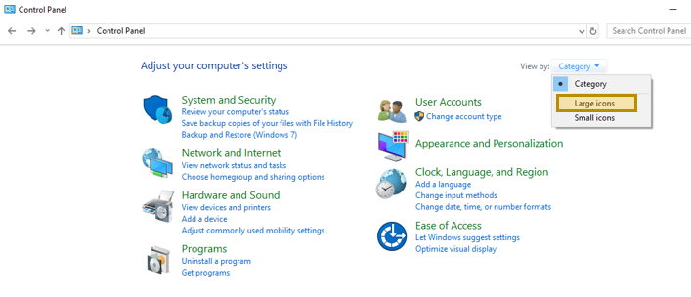

* Select “Programs and Features” from the list

NOTE: the purpose of this step is to validate whether legacy Printer Software has been installed on the machine you are using. This is done to prevent compatibility issues.

Look for: “**HP Universal Print Driver**”, “**UPD**”, “**Universal Print Drive**r” application. You may have a lot of preinstalled applications, starting with HP, just make sure there is none with the above names

* In case there are no such apps, proceed to next step
* **In case there is such app, consider the following**. You may need to uninstall it first. If you are hesitating, you may proceed without uninstallation, however there is a risk that the whole process may need to be restarted, in case you experience issues printing, upon completing the guide.

**Note**: Latest UPD software doesn’t create an entry in the “Programs and Features” section in your OS, but rather creates a Printer directly.

# Downloading the software

* Open a web-browser and visit the following URL:

<https://www8.hp.com/us/en/solutions/business-solutions/printingsolutions/upd.html>

In case link is no longer valid, search for “hp universal print driver” and visit the search result that best matches HP official link for Printing Solutions.

* Select: [Download the HP Universal Print Driver](https://support.hp.com/us-en/drivers/selfservice/UPD/4157320/model/4157320?openCLC=true)

(if you are prompted to select a country, go ahead and proceed)

Your operating system will be automatically detected and you will be provided the list of applicable tools for you.

* Look for HP Universal Print Driver for Windows PCL6 (64-bit)

Note: You may have a valid reason to use the PostScript driver version, instead of the PCL6. If this is the case, proceed with it. For regular business use, PCL6 is preferred)

* Download the installation package on your machine.

Filename should be something like: upd-pcl6-x64-6.6.5.23510.exe



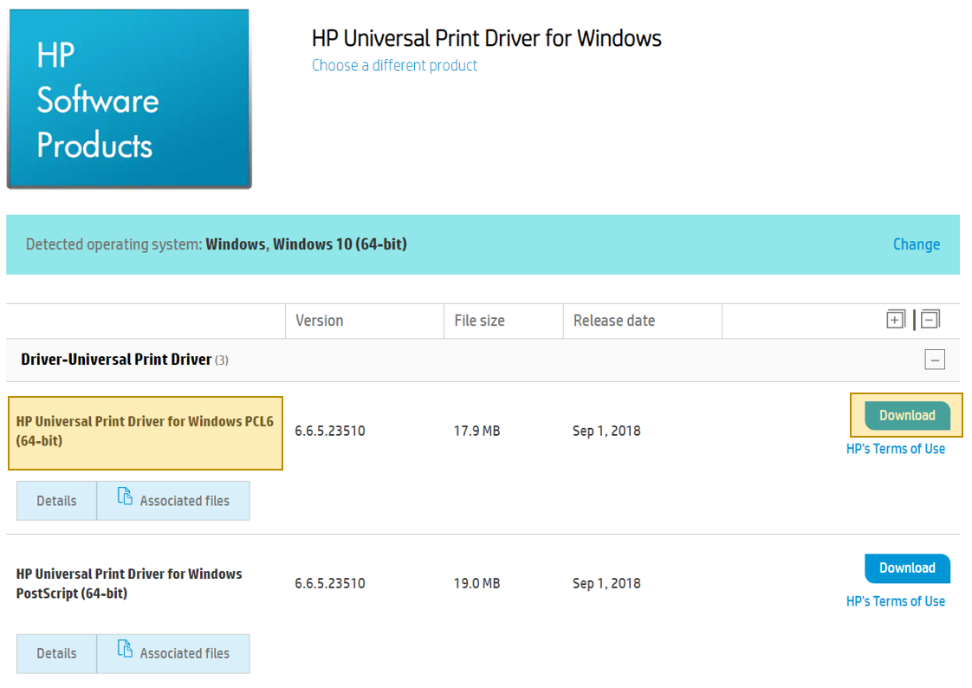

# Installing the software

* Run the executable

You will note that this is a WinZip Self Extractor Package, hit the Unzip button.

* Installer will start automatically upon extraction
* At some point you will be asked to select the Driver operating mode:

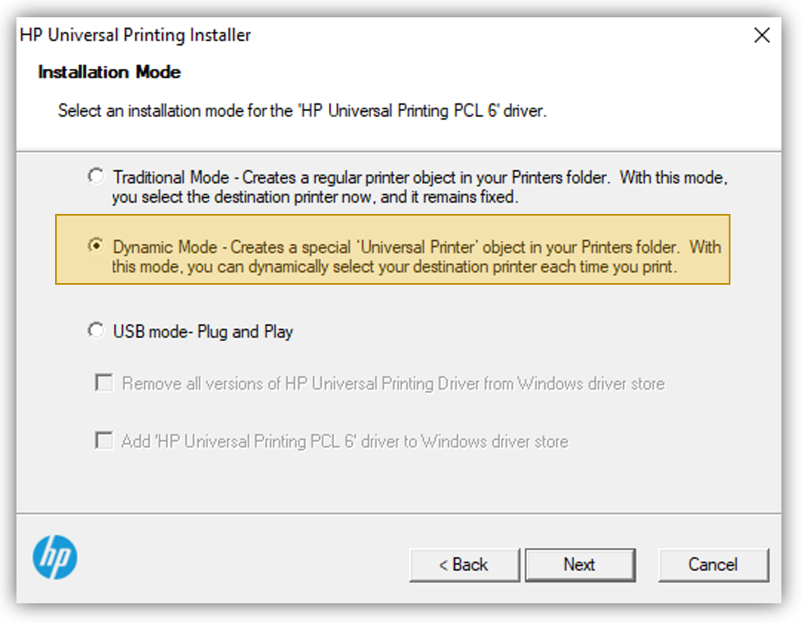

* Choose Dynamic Mode.

*Note*: **Traditional mode** creates a permanent object in the printers list in your OS, where a specific printer is always available and you can address it directly.

**Dynamic mode** will open a dialog asking you which printer you would like to use each time. It may seem like a redundant extra step, however from experience this has proven to be a more convenient approach. Keep in mind the scope of the company, the number of buildings and floors in DXC Sofia alone and the printers across the floors. You will soon start cluttering the Printers area in your OS, that could potentially impact your user experience.

* Continue with the installation wizard until it is Complete.

# Adding printers

* Unlike the traditional approach where a printer needs to be setup first, using UPD starts the other way around. Remember UPD is already installed on your machine and acts as a Gateway to all available and compatible printers in your immediate network.
* Find a convenient printer near your location: (you may need to search for a small room with the sign “Print Room” near it)
* Look for an information poster above the printer.
* Note the Printer address: It may appear in the form of a host address on the Corporate network or an IP address.

An example printer Address would be: sov01p139.emea.hpqcorp.net

This address corresponds to the HP Color LaserJet M775 MFP machine, in Sofia, BG, Business park, bldg.9 2nd floor, left wing, near the entrance door at the time of the creation of this guide.

Note: in case there is no Printer Information Poster above it, you may want to enter the administration panel and find the IP/host address yourself. Changing settings on the printer would require elevated user rights and you will likely not have the authority to do so, however exercise caution and do not attempt saving settings in the printer control panel.

# Printing

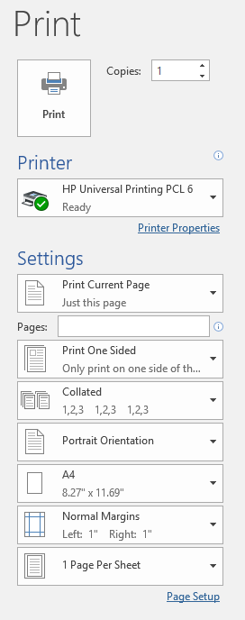

Hit Print, you may see a dialog window, asking you for printout configuration settings, such as the example from Microsoft Word above.

Continue until you see a dialog like the one below:

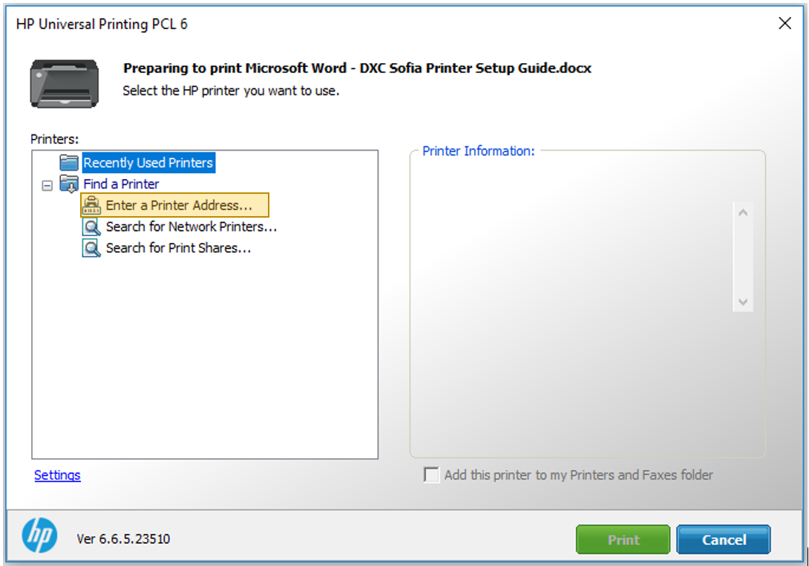

Select “Enter a Printer Address”

Note: You may want to search for Network printers, however this is activity is time consuming and is easier to address the device of your preference directly.

* Enter the device Host/IP Address in the dialog box.

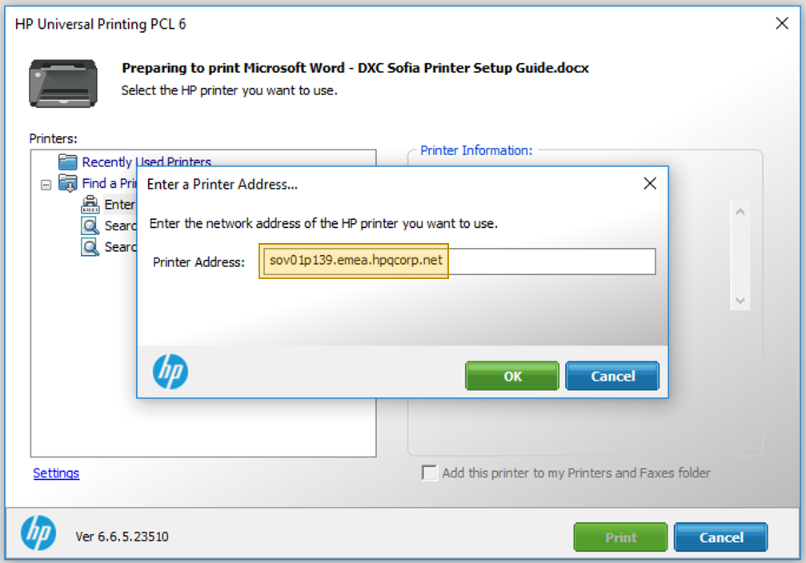

If you have noted down the address correctly, upon clicking OK you will have the ability to select the respective printer on the next screen.

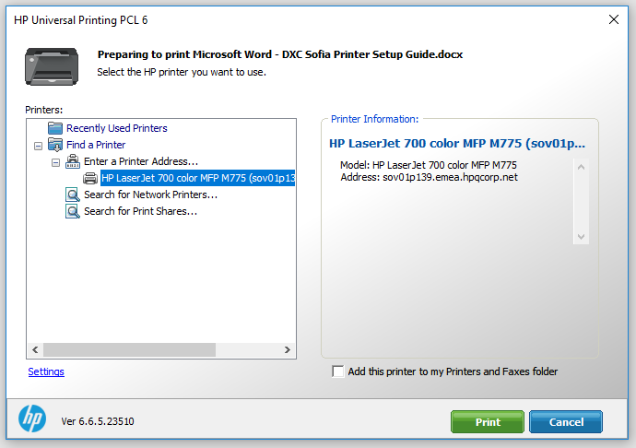

Next time you attempt printing, you will see the same printer in the list of Recently Used Printers.

